

**COS80001 – Cloud Engineering**

**Lab 7 Report:** Virtual Cloud Network (VCN) Peering and Compute Instance Deployment in Oracle Cloud Infrastructure (OCI)

**Student Name:** Arun Ragavendhar Arunachalam Palaniyappan  
**Student ID:** 104837257  
**Tutorial Time:** Friday – 04:30 PM to 06:30 PM

# **1. Introduction**

This report documents the implementation of Virtual Cloud Network (VCN) peering and compute instance creation on Oracle Cloud Infrastructure (OCI). The aim of the lab was to create two separate VCNs, configure internet gateways, set up routing and security, deploy compute instances, establish a local peering connection, test the communication between instances using an ICMP ping, and finally delete the created resources and clean up the environment.

## **1.1 Creating Compartments**

Two separate compartments were created under the (s104837257) root compartment.

* Assignments_Compartment – for the upcoming assignments 2 and assignments 3.
* Labs_Compartment – for the labs 7, 8, 9, 10.

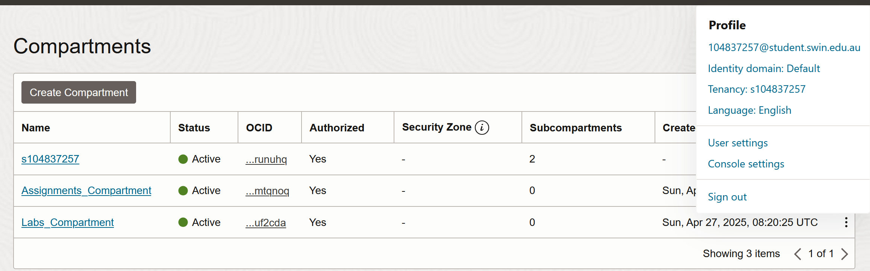

Figure 1: Assignments and Labs – Compartments created

# **2. Task 1: Generating SSH Key pair**

An SSH key pair was generated using Oracle Cloud Shell. The public key was later used during compute instance setup for secure SSH access.

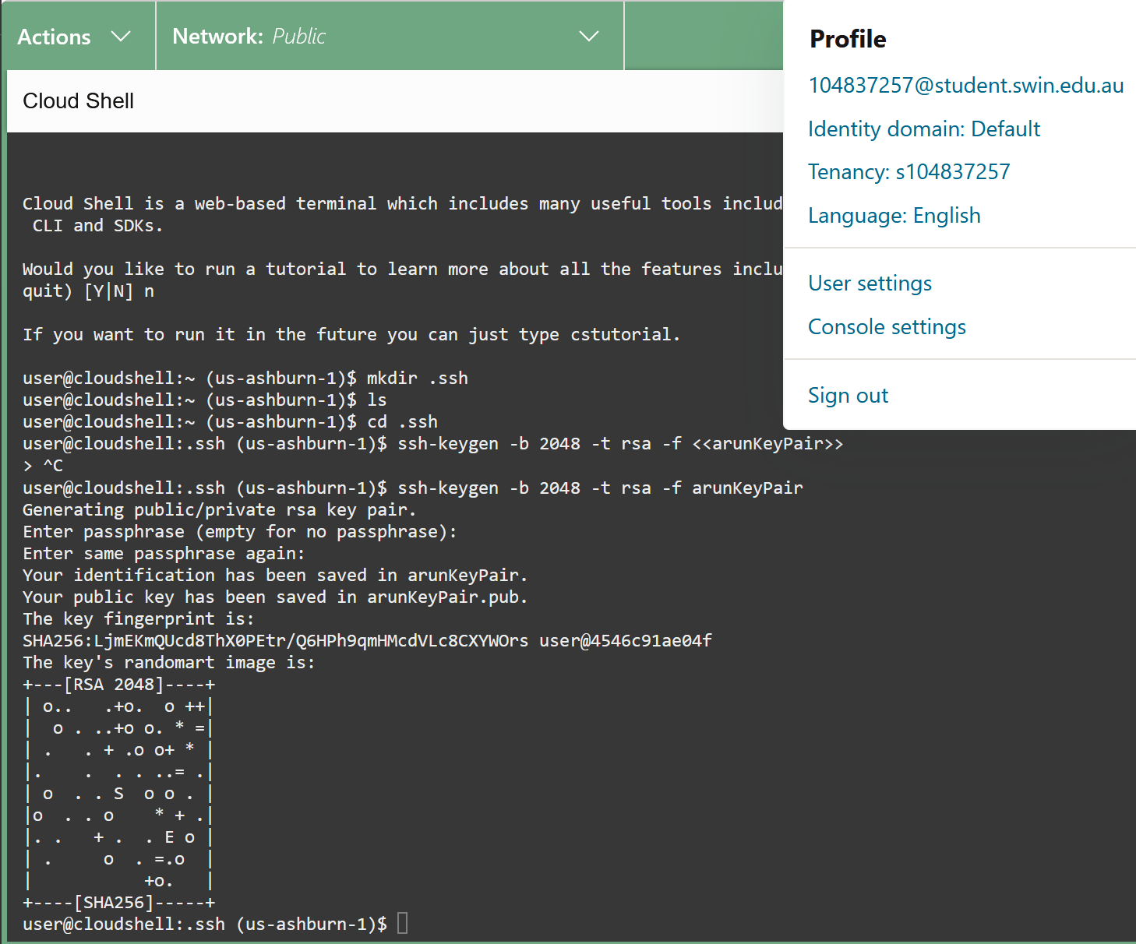

Figure 2: SSH Key Generation



Figure 3: The encrypted SSH key Pair

# **3. Task 2: Configuring Virtual Cloud Network Peering**

## **3.1 Creation of Virtual Cloud Networks**

Two VCNs were created within the Labs_Compartment. The first VCN, named "lab7_vcn_1", used the IPv4 CIDR block 10.0.0.0/16, while the second VCN, named "Peering_vcn", used the CIDR block 172.16.0.0/16.

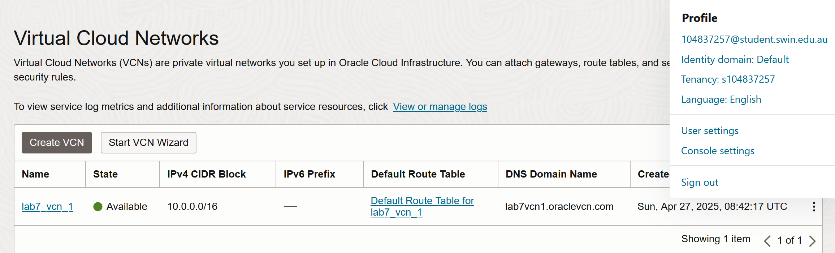

Figure 4: lab7_vcn_1 Creation

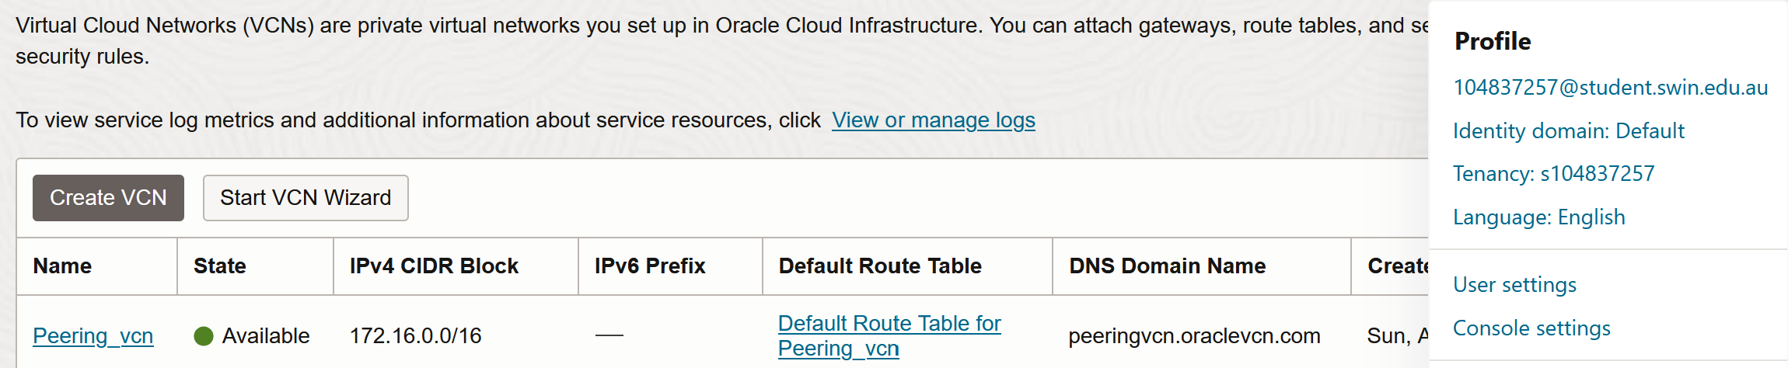

Figure 5: Peering_vcn Creation

## **3.2 Internet Gateways and Route Table Configuration**

Internet Gateways were created for each VCN. In each VCN’s default route table, a new route rule was added to send traffic destined for 0.0.0.0/0 through its respective Internet Gateway, allowing outbound Internet access.

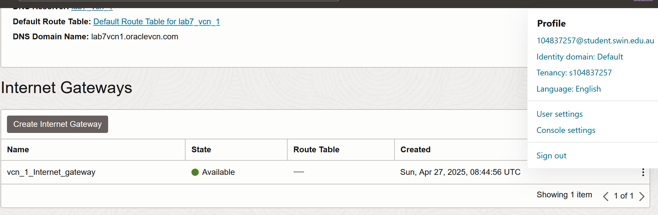

Figure 6: Internet Gateway created for lab7_vcn_1

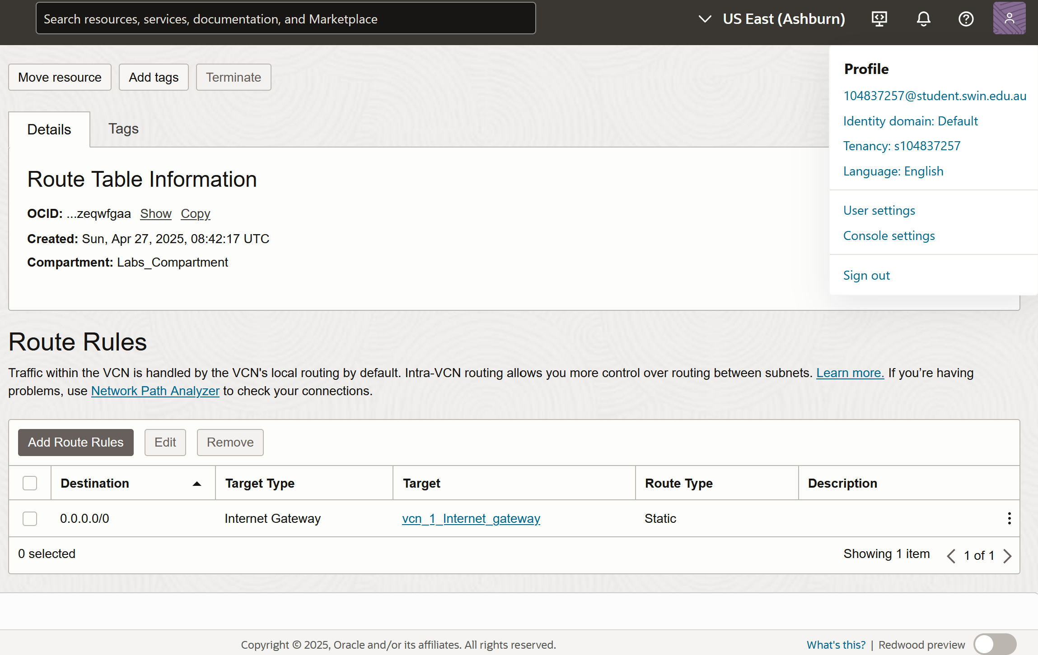

Figure 7: Route to internet gateway added in route table of lab7_vcn_1

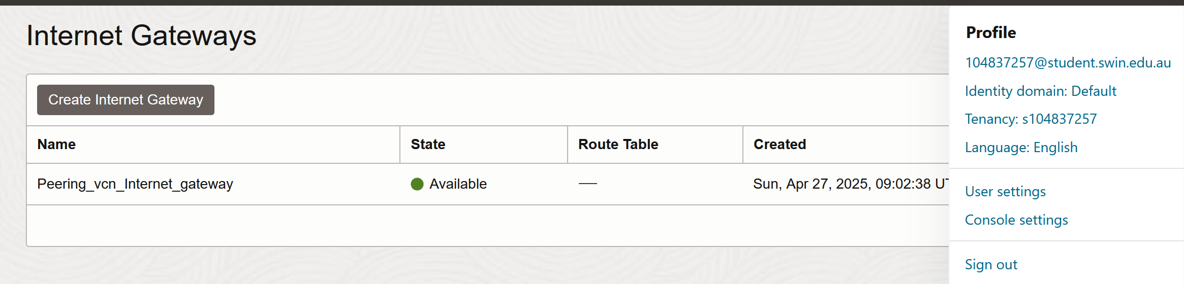

Figure 8: Internet Gateway created for Peering_vcn

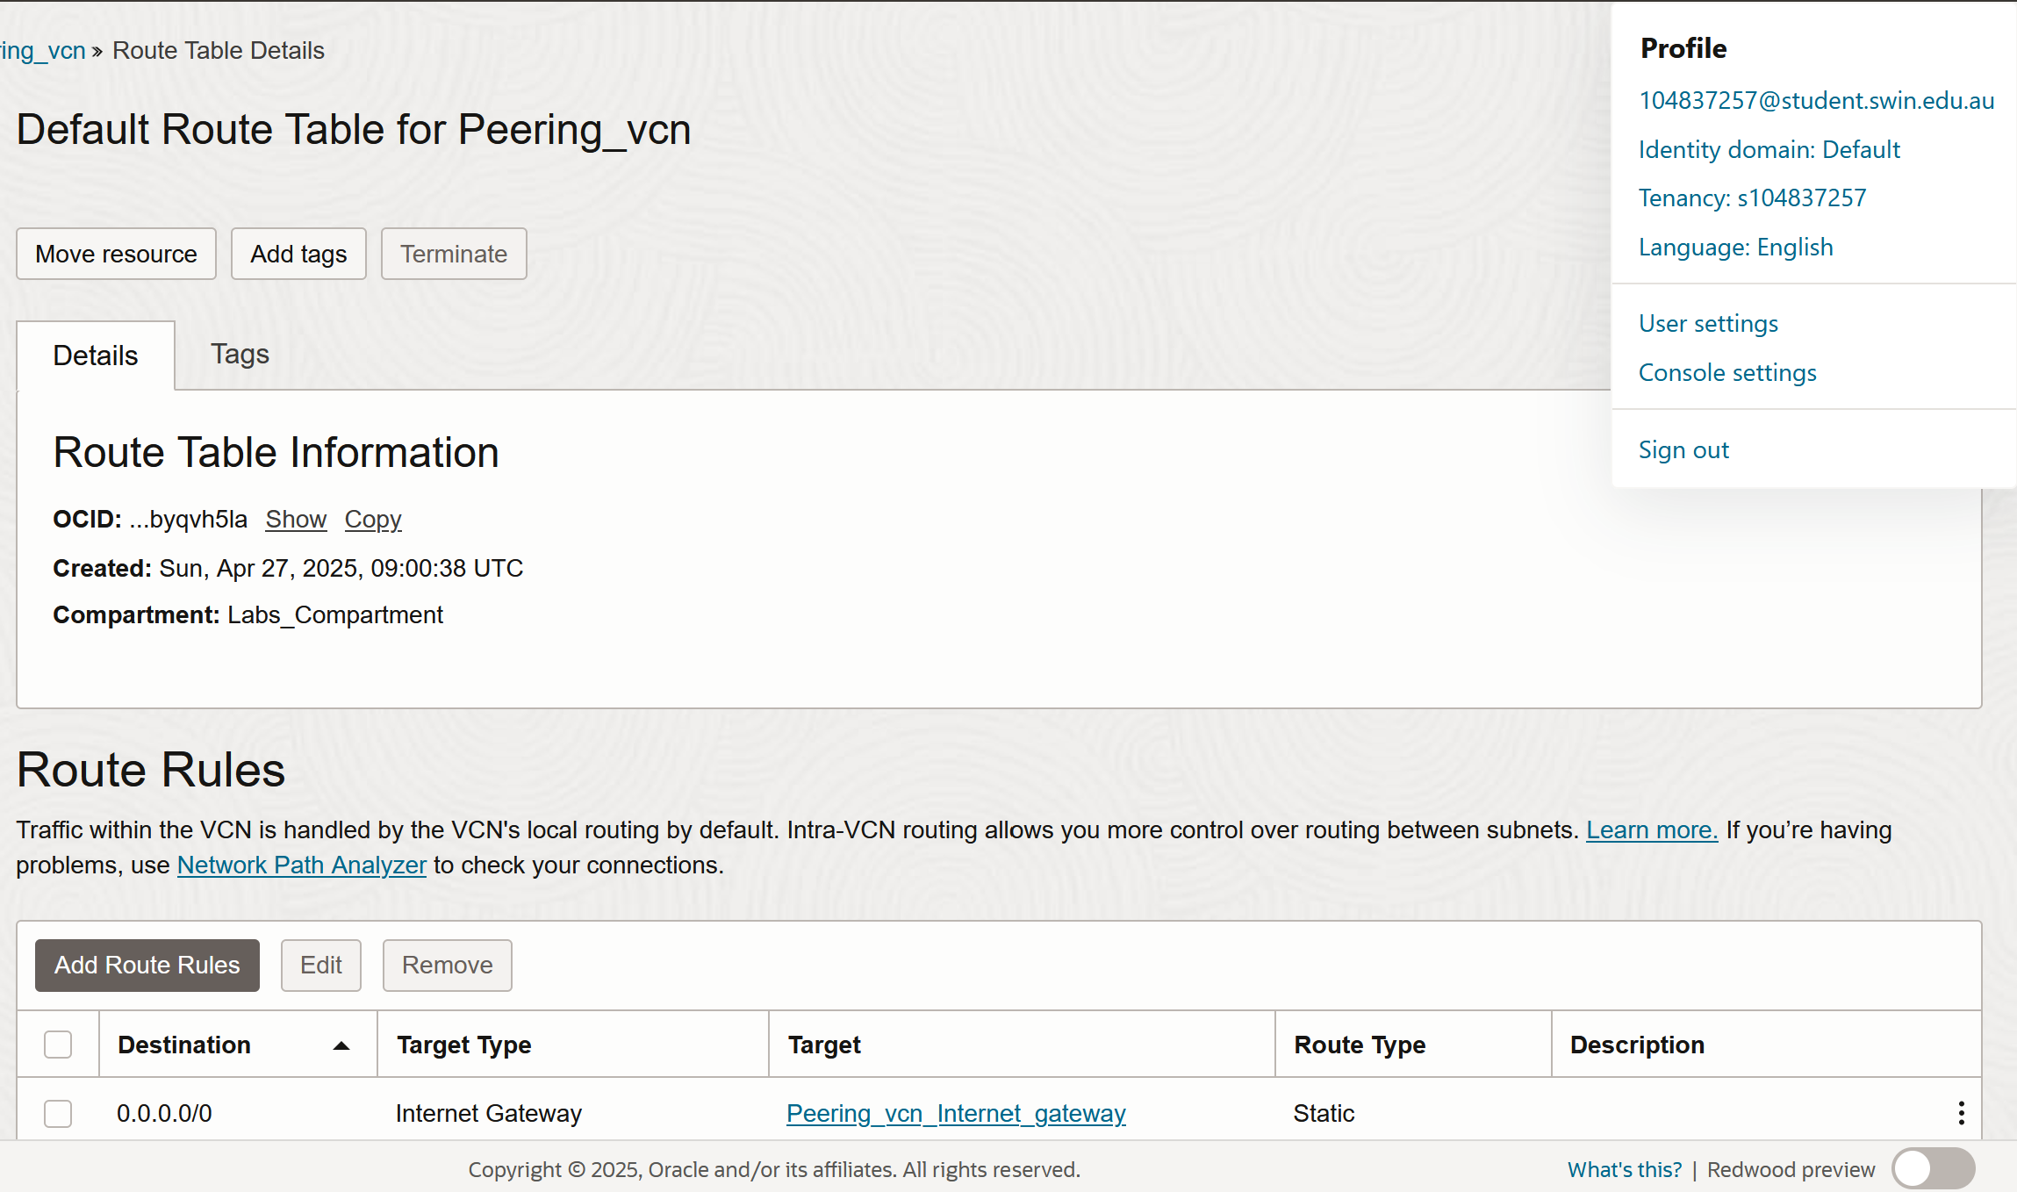

Figure 9: Route to internet gateway added in route table of Peering_vcn

## **3.3 Subnet Creation**

Each VCN was configured with one public regional subnet:

* lab7_vcn_1: Subnet CIDR block 10.0.0.0/24
* Peering_vcn: Subnet CIDR block 172.16.0.0/24

Both subnets were associated with their VCN’s default route table and default security list.

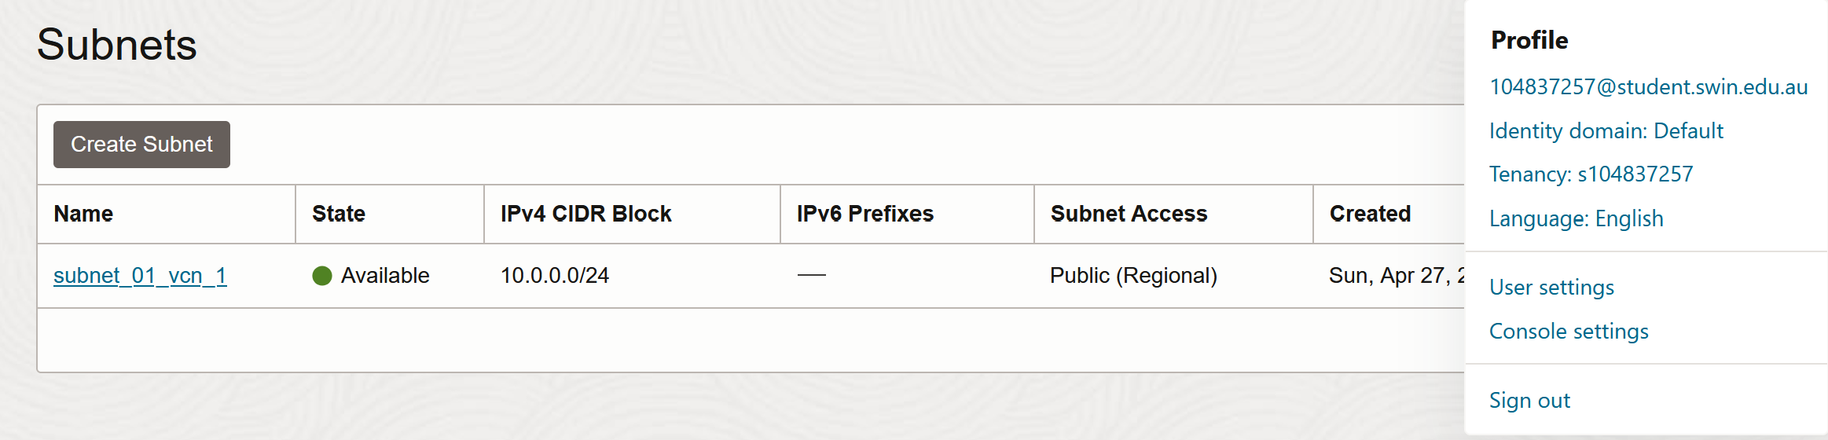

Figure 10: Subnet Creation for lab7_vcn_1

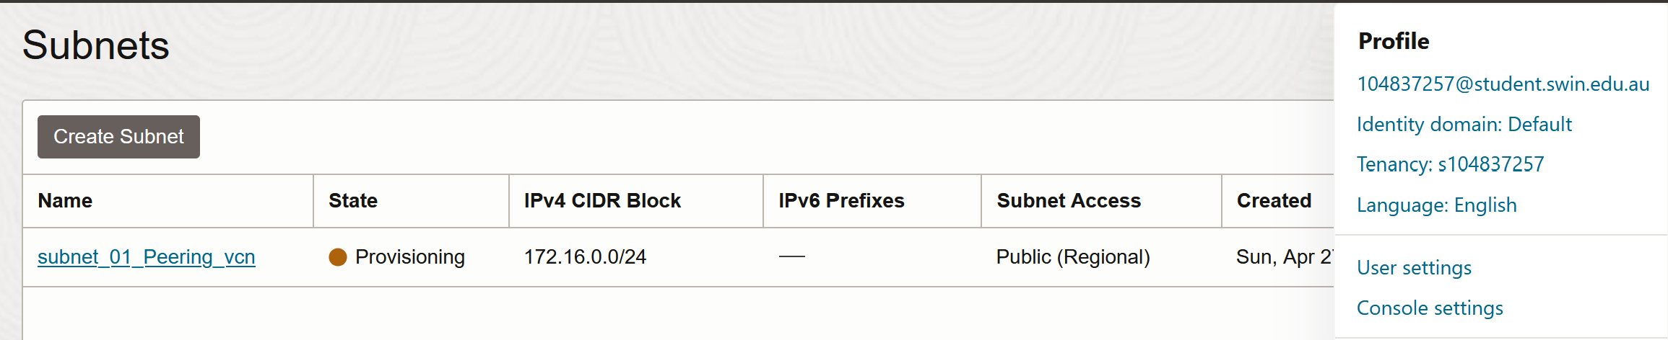

Figure 11: Subnet Creation for Peering_vcn

## **3.4 Local Peering Gateways**

Local Peering Gateways (LPGs) were created for both VCNs. "lpg_01_vcn_01" was associated with vcn_1, and "lpg_01_Peering_vcn" with Peering_vcn. These gateways were required to enable private IP communication between the two compute instances located one each in the two VCNs.

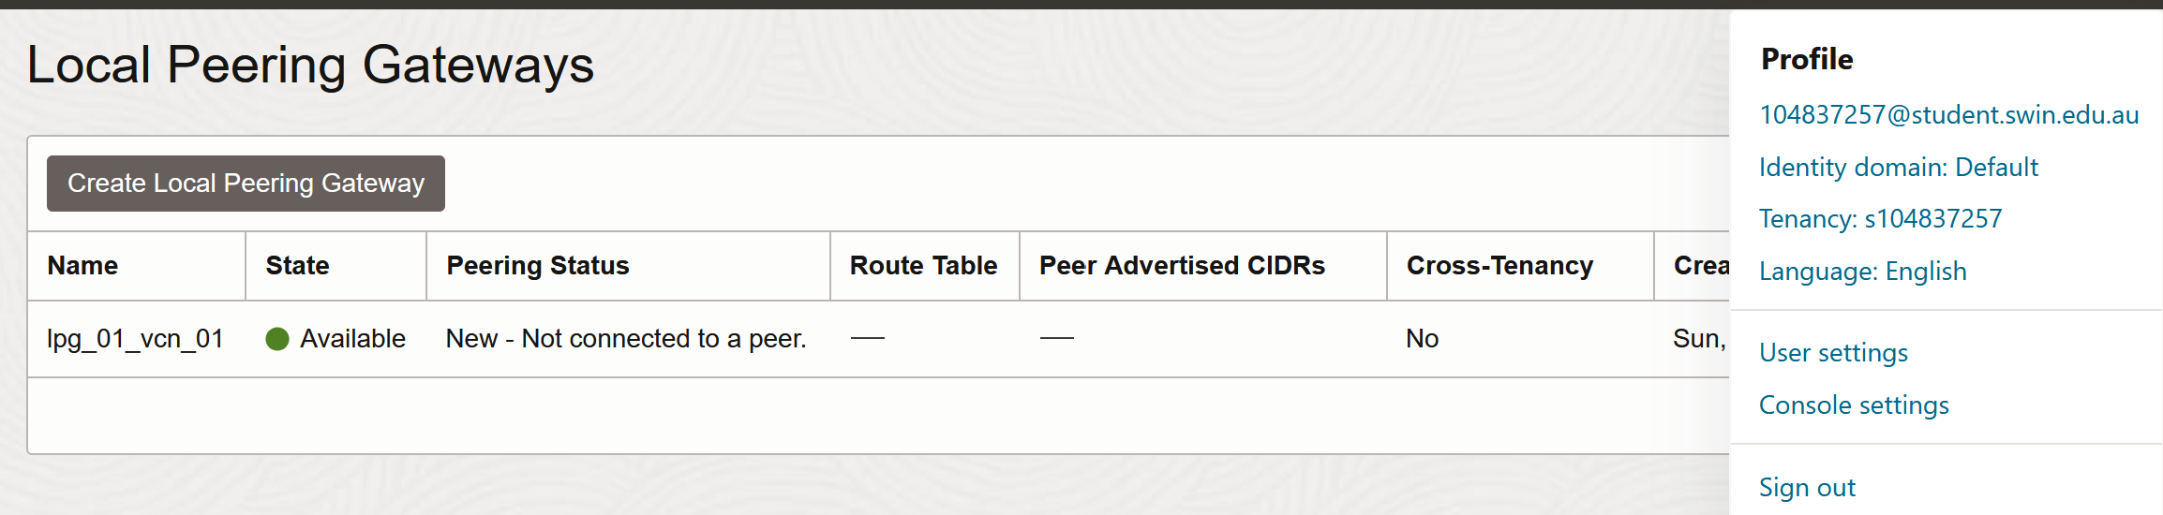

Figure 12: Local peering gateway created for lab7_vcn_1

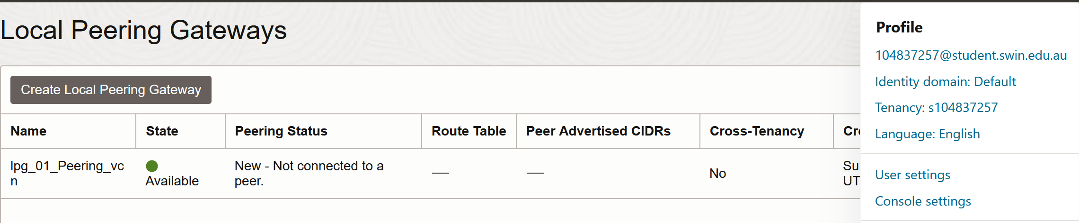

Figure 13: Local peering gateway created for Peering_vcn

# **4. Task 3: Creating Compute Instances and Configuring Routing**

## **4.1 Compute Instance Deployment**

Two compute instances were launched:

* instance01 in lab7_vcn_1
* instance02 in Peering_vcn

Each instance used the latest Oracle Linux image, was assigned a public and private IP address, and SSH access was enabled using the generated public key. Network Security Groups were not used; only the default security lists controlled traffic.

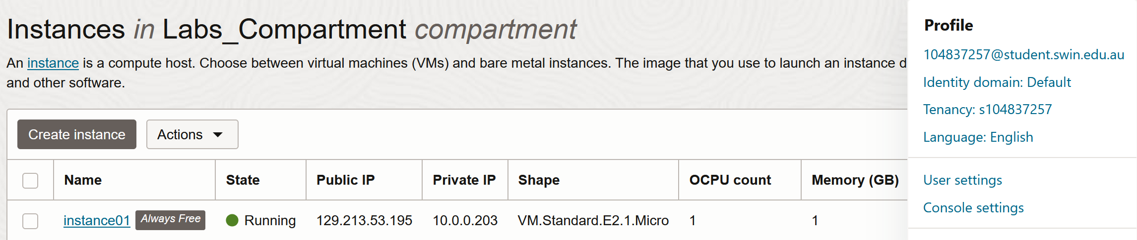

Figure 14: instance01 creation

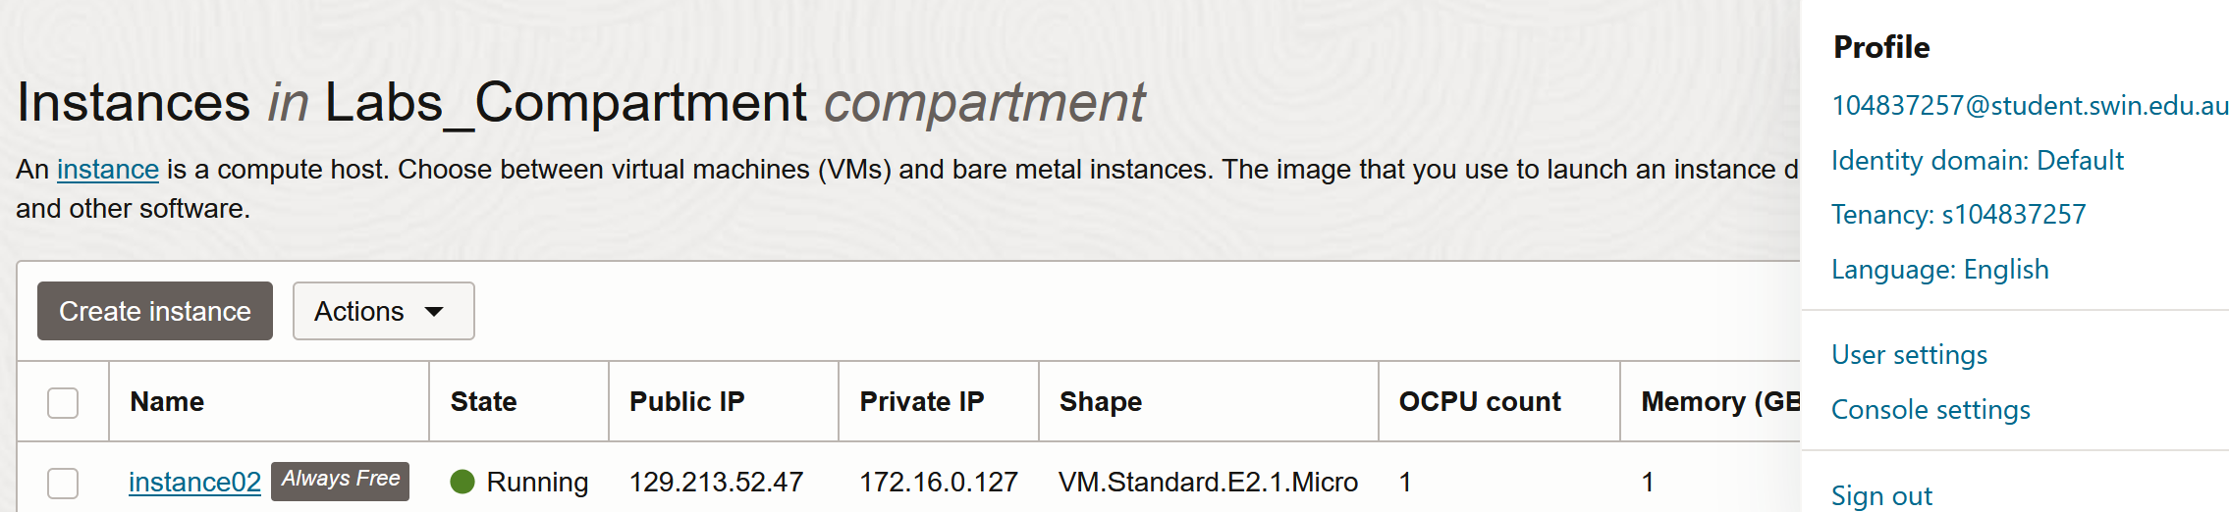

Figure 15: instance02 creation

## **4.2 Establishing Peering Connection**

The LPG in vcn_1 (lpg_01_vcn_01) was connected to the LPG in Peering_vcn (lpg_01_Peering_vcn) through an Establish Peering Connection operation. The peering status was verified to show "Peered".

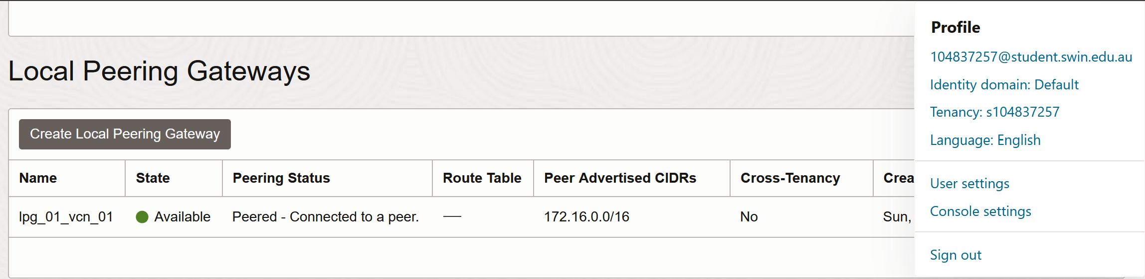

Figure 16: Peered status verified from lpg_01_vcn_01

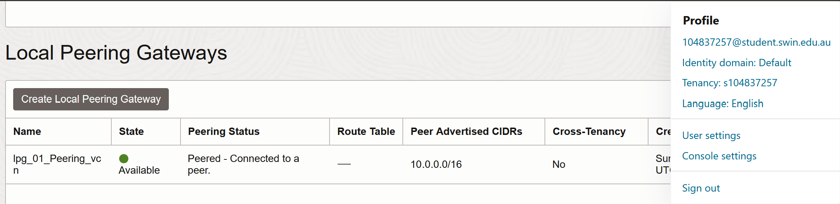

Figure 17: Peered status verified from lpg_01_Peering_vcn

## **4.3 Route Table and Security List Configuration**

In lab7_vcn_1, a new route rule was added to send traffic to 172.16.0.0/24 via lpg_01_vcn_01.

Similarly, Peering_vcn’s route table was updated to send traffic to 10.0.0.0/24 via lpg_01_Peering_vcn.

Security list ingress rules were updated in both VCNs:

* lab7_vcn_1 allowed ICMP traffic from 172.16.0.0/24
* Peering_vcn allowed ICMP traffic from 10.0.0.0/24

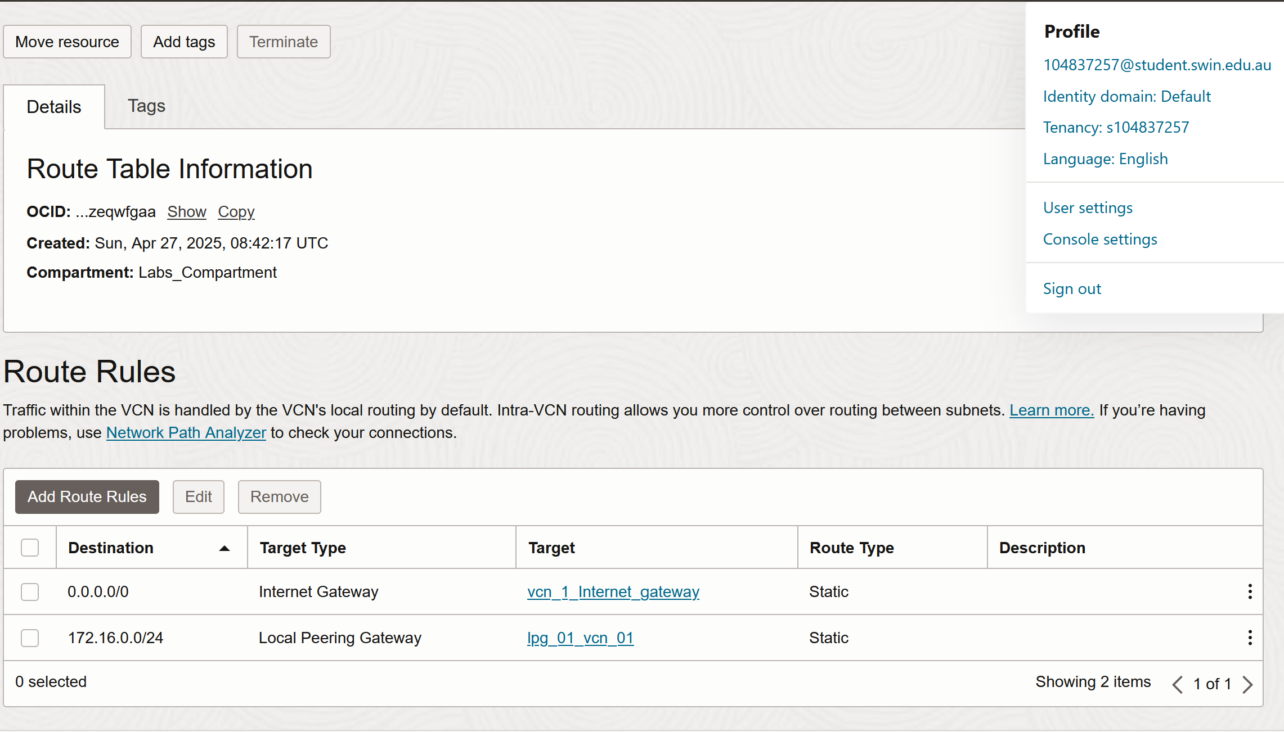

Figure 18: Route rule added in lab7_vcn_1

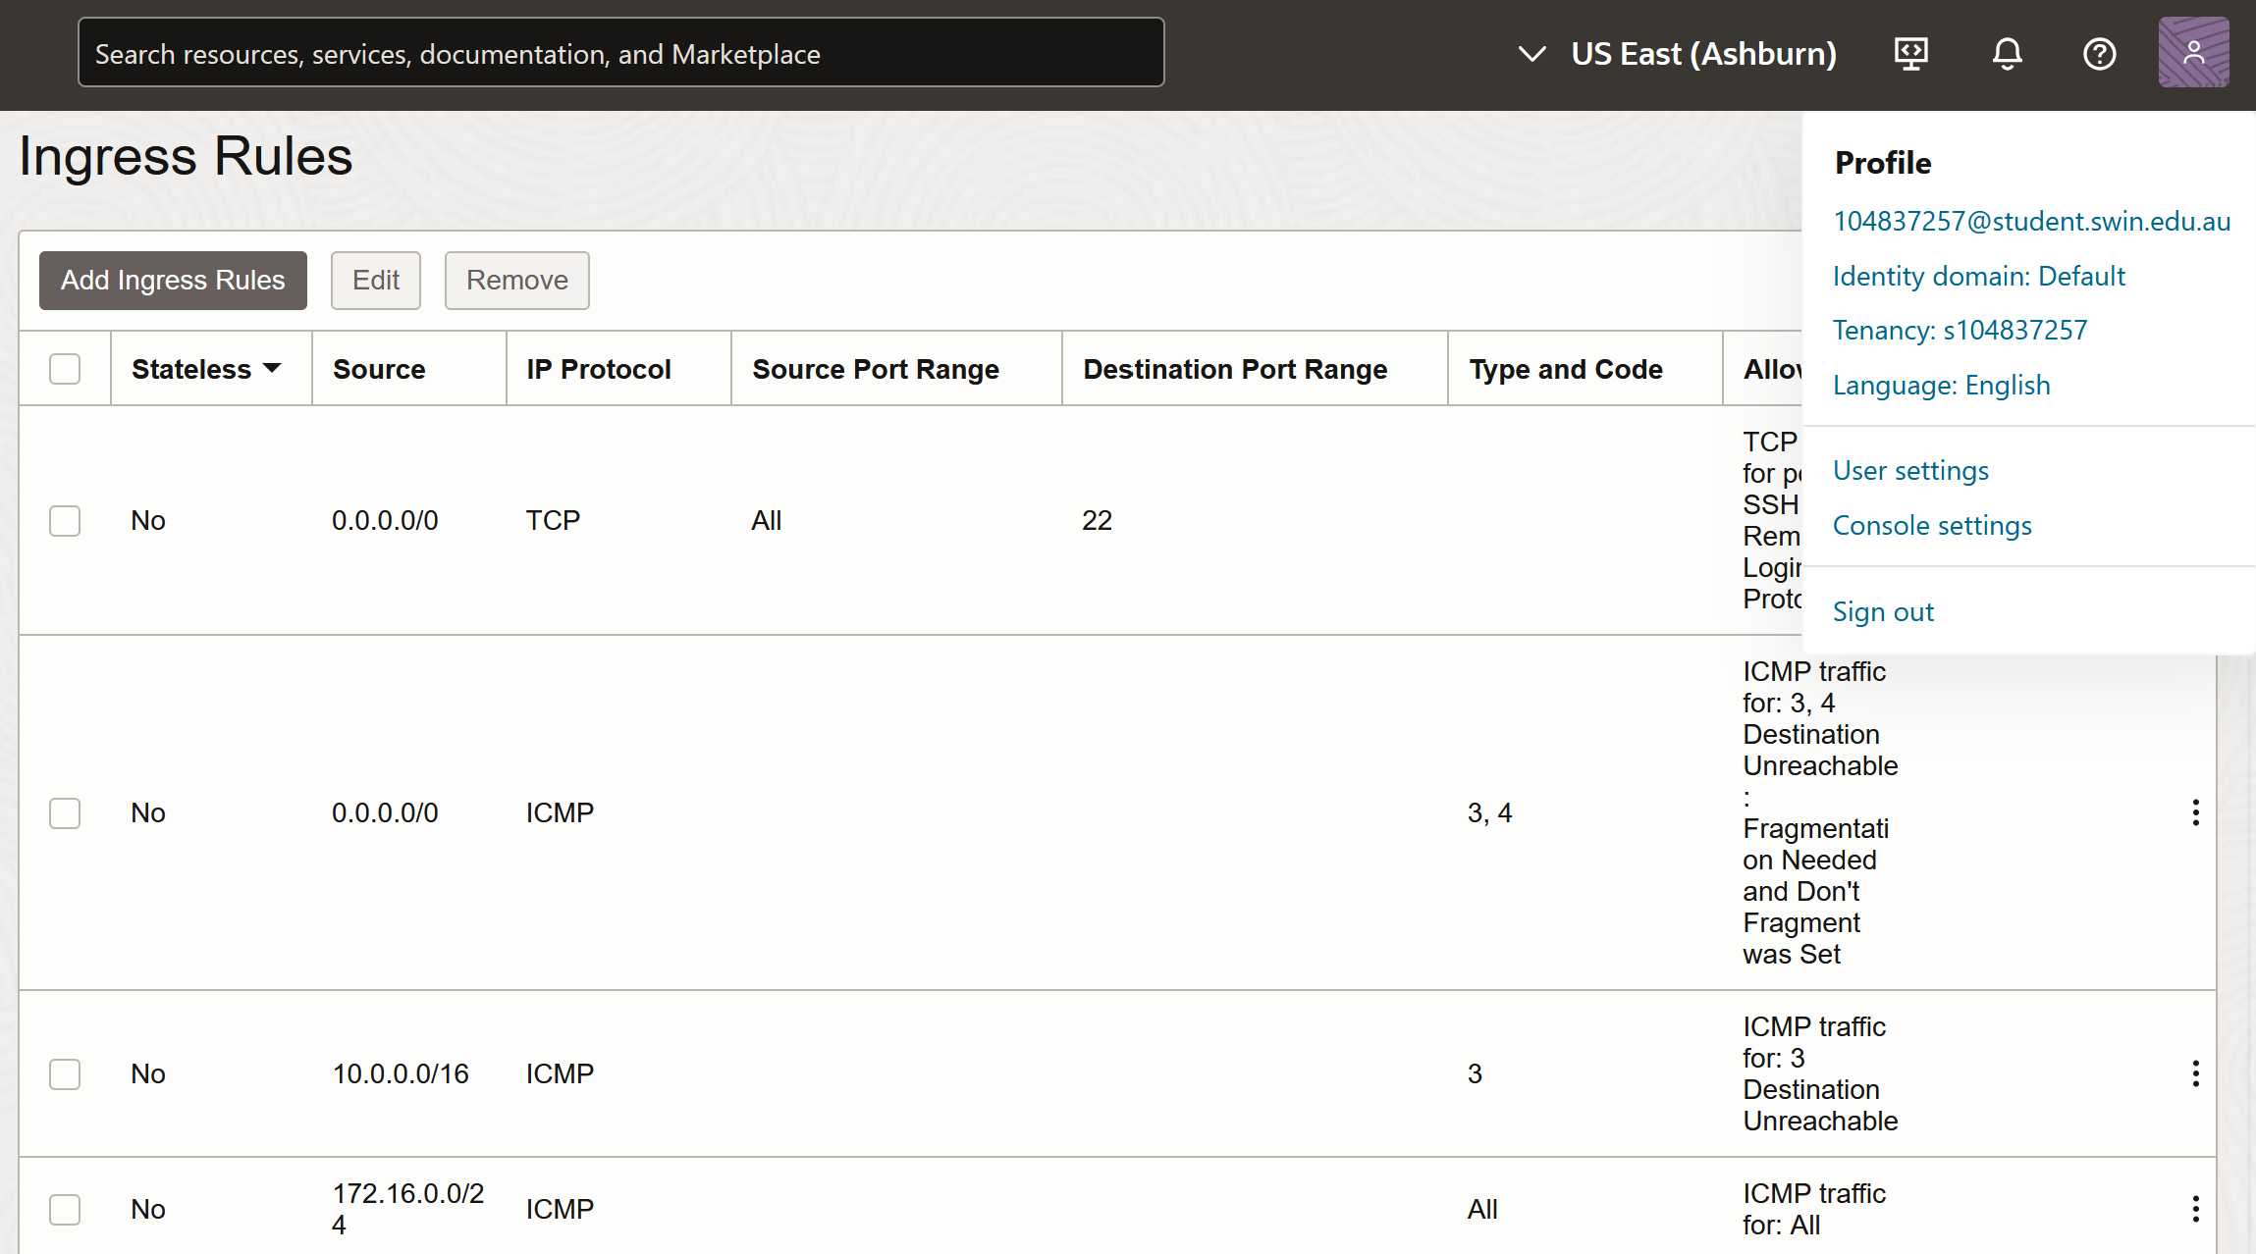

Figure 19: Ingress rule in lab7_vcn_1 to let in ICMP requests from Peering_vcn

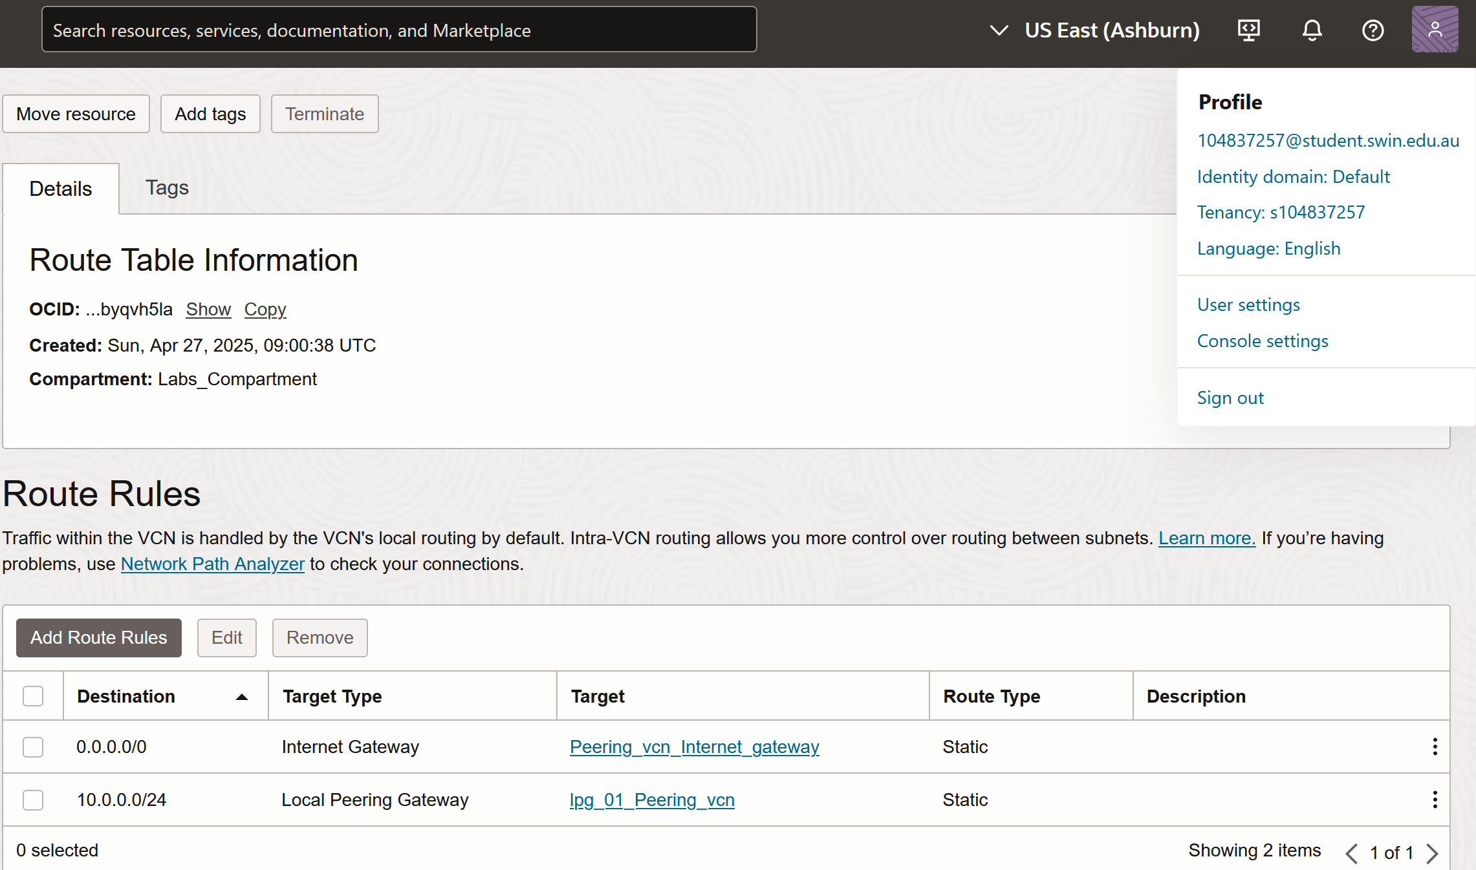

Figure 20: Route rule added in Peering_vcn

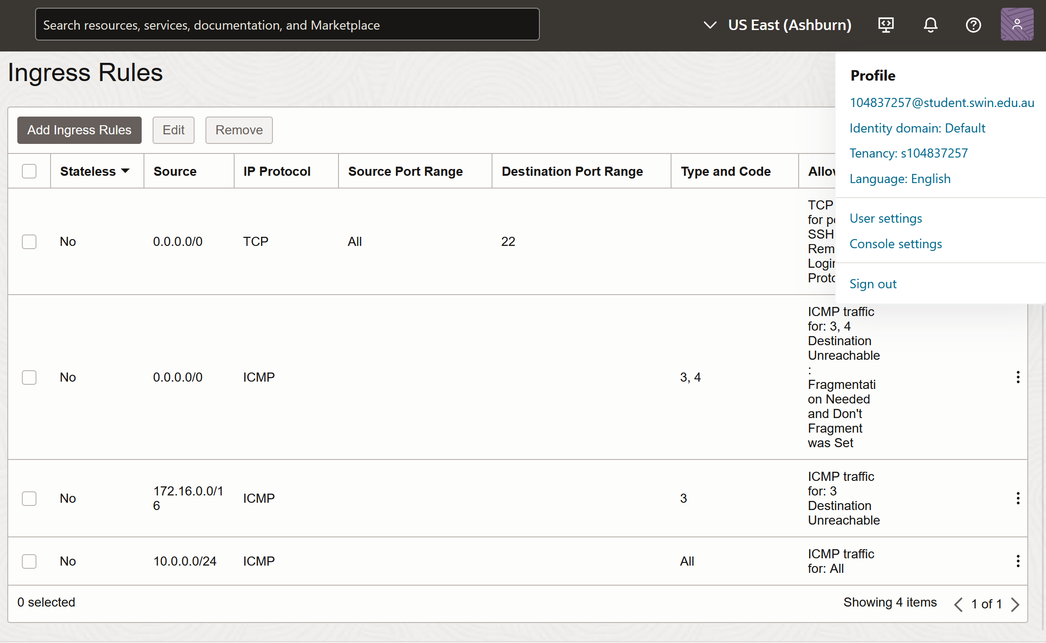

Figure 21: Ingress rule in Peering_vcn to let in ICMP requests from lab7_vcn_1

# **5. Task 4: SSH to Compute Instance and Test VCN Peering**

Using Oracle Cloud Shell, an SSH connection was established to instance01 using the following command:

**ssh -i arunKeyPair opc@129.213.53.195**

Upon successful login, a ping command was issued from instance01 using the private IP of instance02.

**ping 172.16.0.127**

The ping was successful, verifying that the peering connection was functional, and the routing and security configurations were correct.

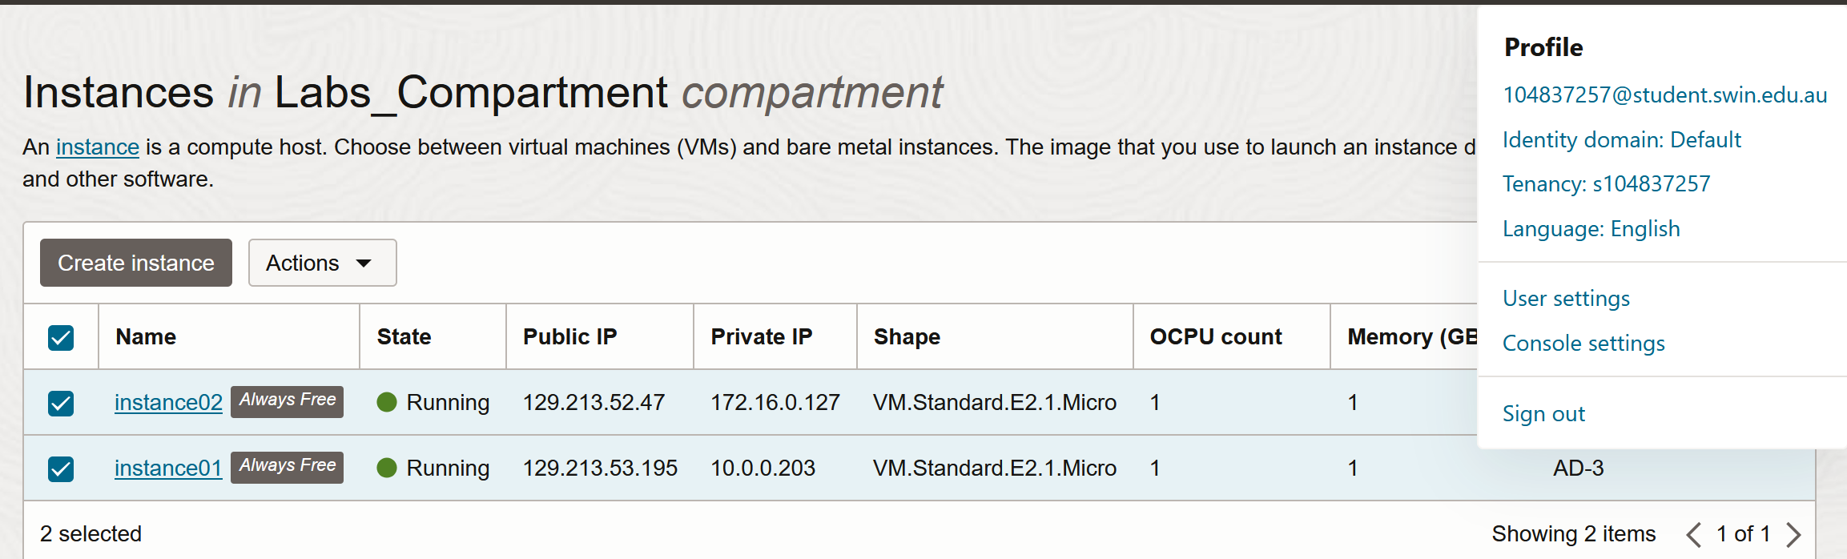

Figure 22: Public and Private IP addresses of instance1 and instance2

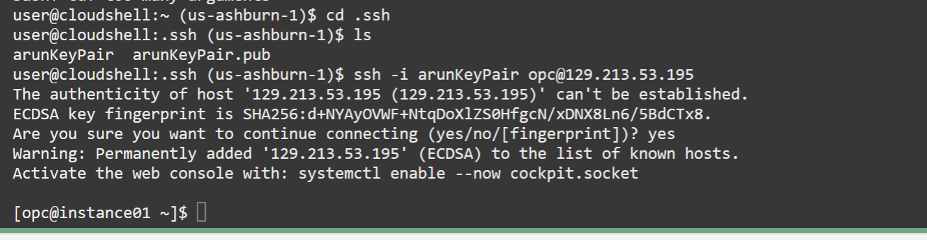

Figure 23: SSH login to instance1 using its Public IP address using the key pair for authentication

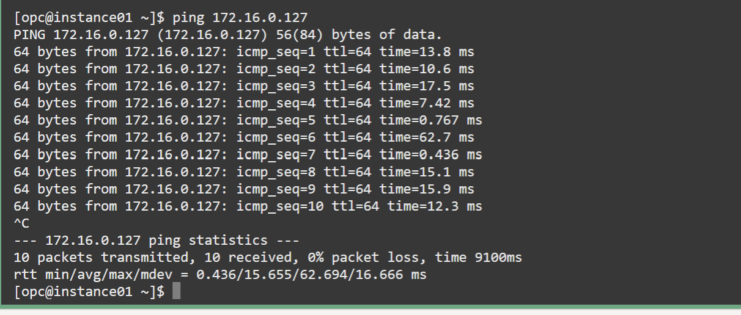

Figure 24: ICMP ping from instance1 to instance 2 using the private Ip address of instance2

# **6. Task 5: Deleting and Terminating Resources**

After verification, both compute instances were terminated along with their associated boot volumes. Both VCNs were deleted to clean up all cloud resources, following best practices to avoid unnecessary costs and clutter.

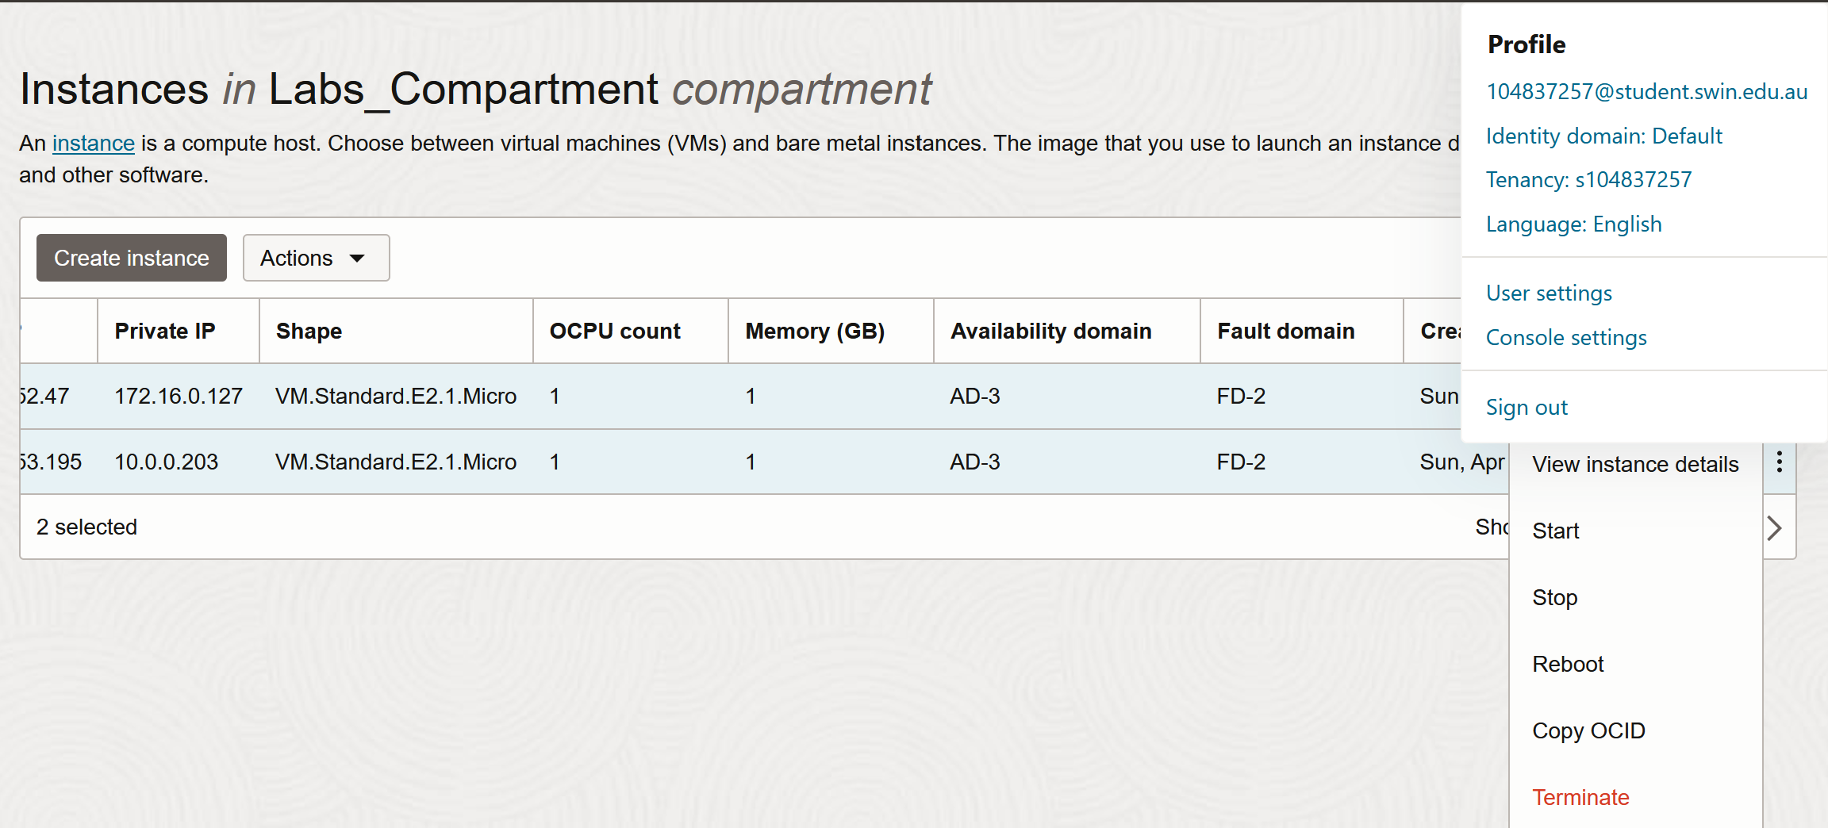

Figure 25: selecting both instances and opening the action button to access the Terminate option

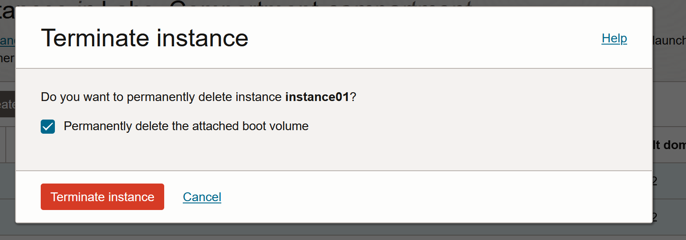

Figure 26: Terminating the Compute instances

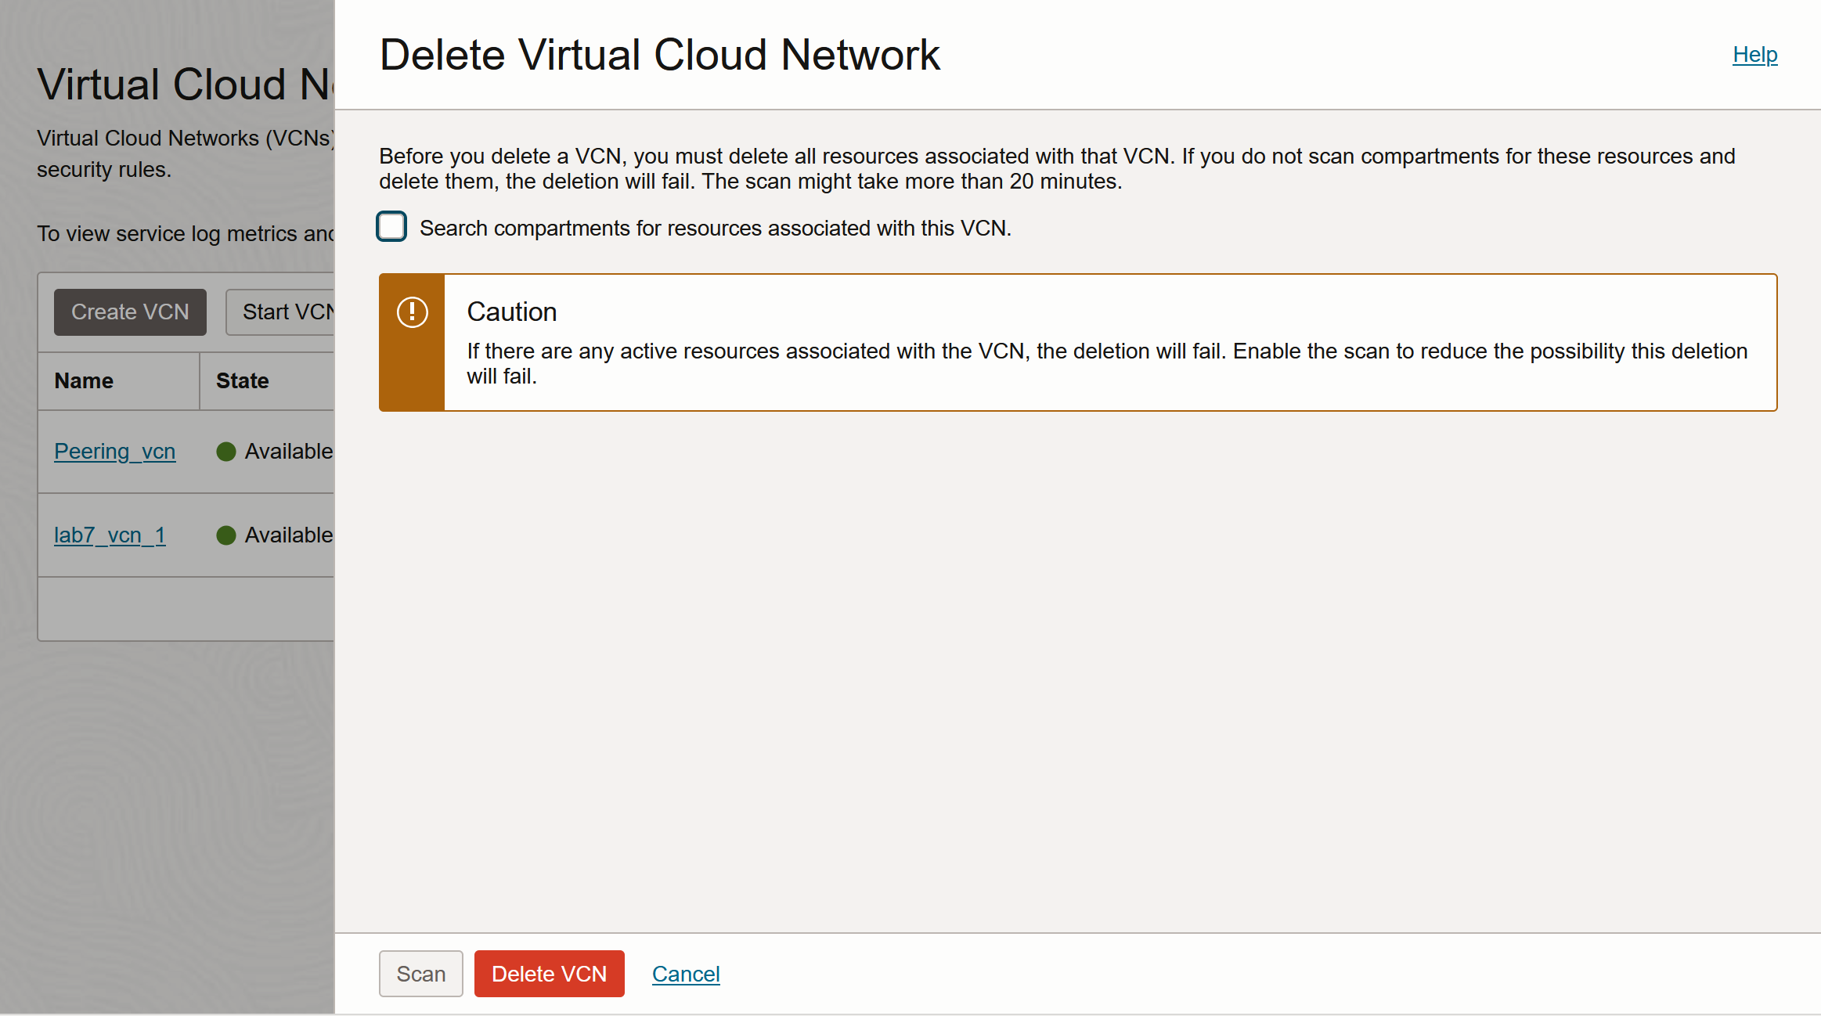

Figure 27: Deleting both the VCNs which were created

# **7. Conclusion**

This lab showed how to create two Virtual Cloud Networks (VCNs) in Oracle Cloud, connect them using local peering, set up routing and security, and check if the instances could talk to each other privately using ICMP ping. It helped in understanding basic cloud networking concepts like how VCNs, subnets, routes, gateways, and security settings work together in the Oracle cloud environment.

# **8. References**

[1] Oracle Cloud Infrastructure Documentation. "Virtual Cloud Networks (VCNs)." [Online]. Available: <https://docs.oracle.com/en-us/iaas/Content/Network/Concepts/overview.htm>

[2] Oracle Cloud Infrastructure Documentation. "Local VCN Peering." [Online]. Available: <https://docs.oracle.com/en-us/iaas/Content/Network/Tasks/localVCNpeering.htm>